School Tea Towel
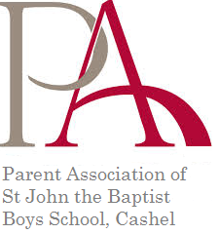
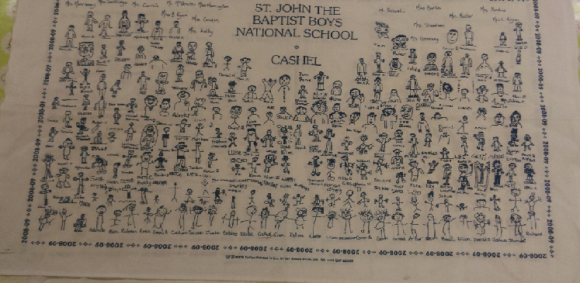
The Parent Association of St John the Baptist Boys National School has asked each of the boys to create a signed self-portrait to create a commemorative tea towel for 2016. This was last completed when the current 6th class was in Junior Infants and so it is a great record of their progress through the school.
If you are interested in purchasing a tea towel please complete the form below and return to the class teacher, with payment, by 3rd June. Cost per tea towel is €5
Name of Student Class
No tea towels Amount included
School Tea Towel
The Parent Association of St John the Baptist Boys National School has asked each of the boys to create a signed self-portrait to create a commemorative tea towel for 2016. This was last completed when the current 6th class was in Junior Infants and so it is a great record of their progress through the school.
If you are interested in purchasing a tea towel please complete the form below and return to the class teacher, with payment, by 3rd June. Cost per tea towel is €5
Name of Student Class
No tea towels Amount included

