Mrs Butler and Mrs Carroll
EAL -English As An Additional Language
Week 27th April to 1st May
Hi boys, we hope you and your families are all well. We are missing you all and we hope you are all staying safe. Mrs Butler has put up a little video for you all to see. Here are some ideas to help practice your English while you are at home if you have time. If any parent wants to email us please do not hesitate to contact us we are here to help. Here are our email addresses: helenbutler@cashelbns.ie and kathrinecarroll@cashelbns.ie
If you like, you can send us a picture of some of your work.
This week we will revise the topic: Myself

Activity 1
Draw a picture of ‘Myself ‘and talk about yourself
Answer the following questions;
What is your name?
What age are you?
Where do you live?
Where do you go to school?
Who is your teacher?
What do you like doing?
What is your favourite toy?

Activity 2

Here is a family. Talk about the picture.
Questions:
How many people are in this family?
What colour is the baby’s jumper?
What are granny and grandad wearing on their faces?
Who is wearing red shoes?

Activity 3
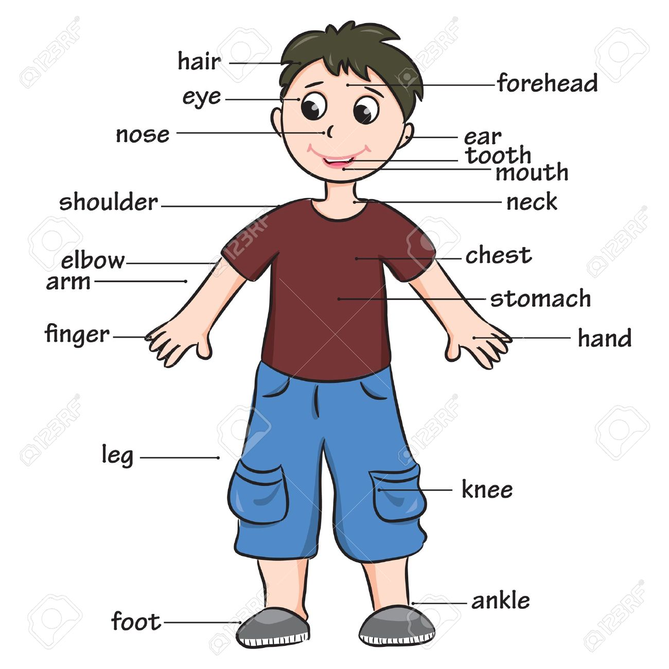
Do you know all these body parts?
What about you:
What colour is your hair?
What colour are your eyes?

